International Workshop on Keel Bone Damage in the commercial laying hen

Date: April 7-9, 2014

Held by the Division of Animal Welfare, VPH Institute, University of Bern, Switzerland

Location: Research Centre for Proper Housing of Poultry and Rabbits, Aviforum, Zollikofen (near Bern), Switzerland

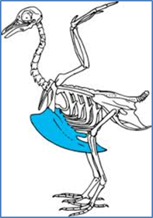Keel bone damage in egg-laying hens is a major animal welfare and farm productivity issue that afflicts upwards of 50% of animals in commercial facilities according to recent published estimates. Although the frequency of damage will vary with a host of factors including housing conditions, nutrition, breed and age, among others, keel bone damage occurs worldwide and is thus truly an international problem. Despite its widespread occurrence, the academic community and egg producers do not fully understand the causes of keel bone damage or how they can be eliminated. In pursuit of identifying solutions for this problem, the first International Keel Bone Damage Workshop was held April 7-9, 2014 at the Research Center for Proper Housing of Poultry and Rabbits, a research facility of the Division of Animal Welfare of the University of Bern based at the Aviforum in Zollikofen near Bern, Switzerland. The workshop brought together over 33 leading researchers and representatives of welfare charities and industry from 3 continents, 10 countries, and 20 institutions to foster collaborative research and resolve key issues which impede progress in resolving bone damage in hens.
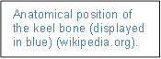Workshop attendees participated in several sessions that were designed to take advantage of this unique opportunity which brought together a broad array of disciplines and expertise. For instance, areas of knowledge represented at the workshop included biomechanics of avian flight, bone structure and biology of the laying hen, behavioural assessment, and genetics. Organizers of the workshop specifically sought a diversity of backgrounds to ensure that novel solutions could be identified with lateral thinking across disciplines.
With the conclusion of the meeting, several key outputs where decided upon that will be produced within the next three months including:
- an agreed-upon format and language for representing keel bone damage to allow consistent documentation and sharing of research across labs
- a summary of key adjustments producers can make to their facilities to reduce keel bone damage
- research experiments that are needed to fill specific gaps in knowledge
The workshop was funded by several organizations including: the Swiss National Science Foundation, the Swiss Federal Food Safety and Veterinary Office, the Universities Federation for Animal Welfare (UFAW), and the United Kingdom`s Biotechnology and Biological Sciences Research Council.

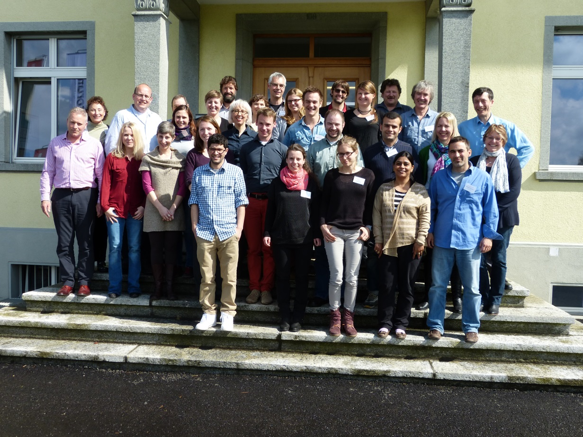

Picture 1. The attendees of the 2014 International Keel Bone Damage Workshop at the entrance to the Aviforum in Zollikofen, Switzerland where the workshop took place.

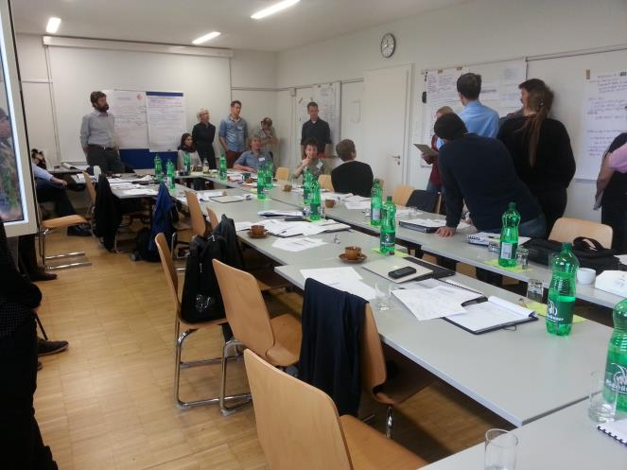

Picture 2. Workshop attendees during one of the sessions.

